INUA NURSE FOOTPRINT (INF)
Office of the Chairperson – NUNSA
Date: 07/09/2025
TO: The Deputy Director Nursing Services, MoH
FROM: Israel Alex Makori, NUNSA Chairperson 2025/2026 – CEO, INF

SUBJECT: Appreciation for Your Remarkable Contribution at the NUNSA White Coat Ceremony

On behalf of the Nairobi University Nursing Students Association (NUNSA) and the entire nursing student body, I extend my heartfelt gratitude to you for honoring our invitation and representing the Ministry of Health at our White Coat Ceremony on 29th August 2025.

Your presence added immense value to the occasion, and your powerful insights on the role of nurses in achieving Universal Health Coverage (UHC) were both inspiring and thought-provoking. You reminded us of the critical place we hold in the healthcare system and the responsibility we carry as future nurses.

Thank you once again for your time, support, and encouragement. We look forward to continued collaboration as we work together to uplift nursing and strengthen healthcare in Kenya.

Warm regards,
Israel Alex Makori
0112569560
alexmakori@students.uonbi.ac.ke
Chairperson – NUNSA 2025/2026
President – Inua Nurse Footprint (INF)

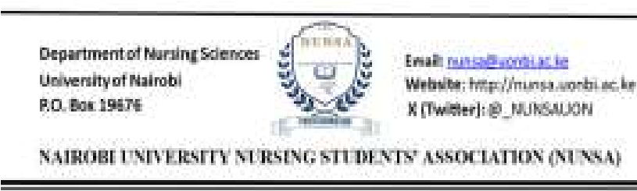


INUA NURSE FOOTPRINT
(
INF
)

P.O BOX 19676
-
00202

Inf.go.ke@gmail.com

+254 112569560

